Task

1. Simulate common mode and differential mode using Choke instead of INDK
2. Varying the parameters simulate the cutoff frequency from 1MHz to above.
3. Identify the S parameter of real time Choke given by professor ( 744202, 744207, 744221, 744222, 744224, 744226, 74279404, 74279450, 74279451, 74279452, 744795080, 744795051)
4. Use these S parameters and simulate the filter circuit.

Approaches

1. Have simulated the circuit and used coupled inductor (choke) putting different values.
2. Varied the value of Differential mode capacitor.
3. Used the S parameter instead of lumped element (ATC multilayer ceramic capacitor, package 1111 )
4. Tried to get the S parameter of the given Chokes but failed. Not even got any equivalent circuit. Eventually there are LT and PSP files supplied by manufacturer but given as embedded format which cannot be used in AWR environment.
5. Identified some possible ways to get the S parameters.
   1. We can make a PCB board where we can align chokes parallel and provide 50 ohm line with every choke and set SMA connector with every choke. Then using vector network analyzer we can measure S parameter of that specific choke. As we have choke and footprint of the corresponding choke package, we can easily built a 2 layer PCB using FR4 material. I am planning to design that PCB using Eagle software.

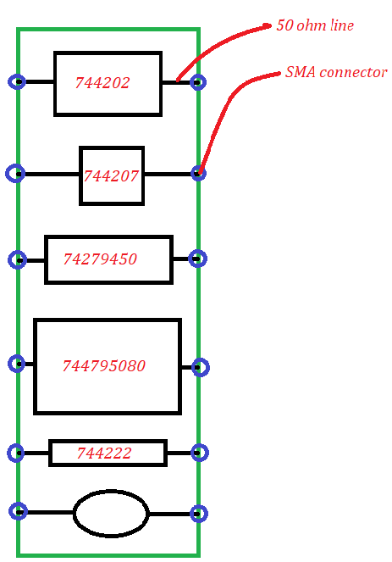

* 1. Using the de embedding process we can measure S parameter of the specific choke as we have the S parameter of the trace and the other passive components.

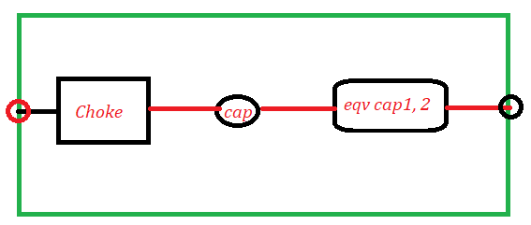

* 1. And if possible we can built both of circuit in the same PCB.

GP7TD-VN3XJ-GB4GR-727V2-7CFBY